**SCREEN SHOTS**

**Course-end Project 1**

**Set Up and Monitor a WordPress Instance**

Step 1:Creating the EC2 Instance

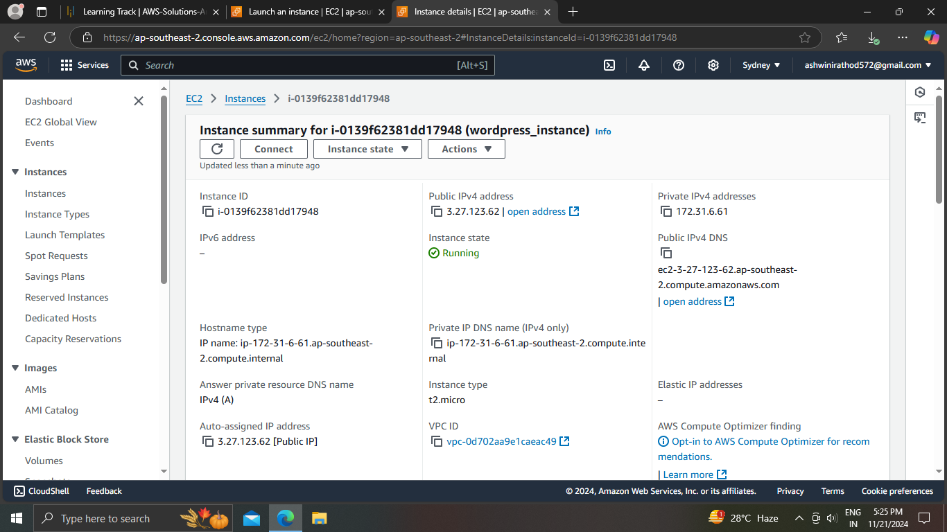

Step 2:Creating WordPress instance by choosing WordPress certified Bitnami AMI

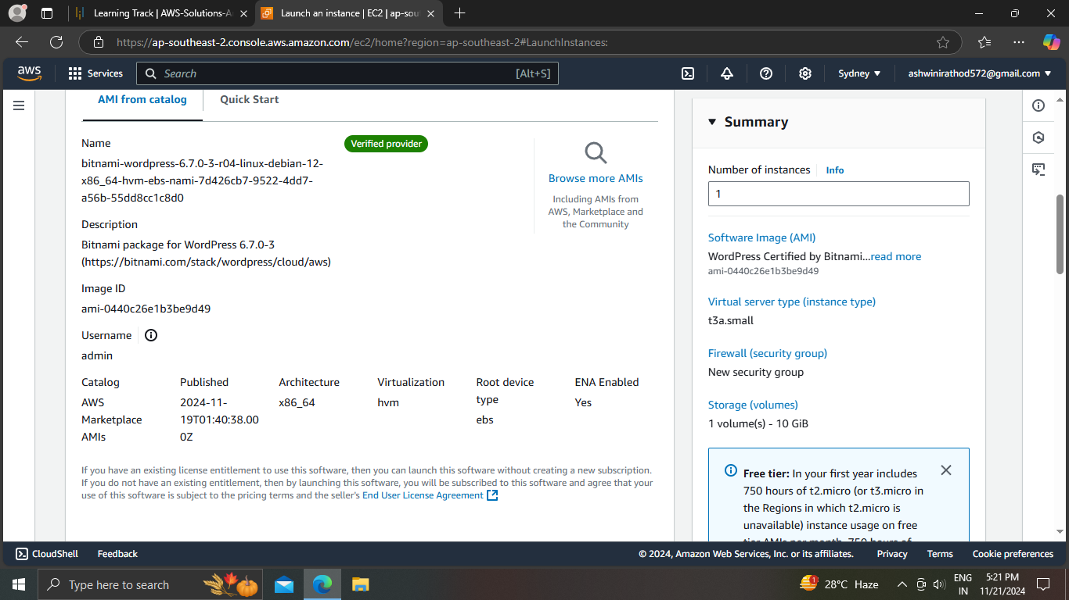

Step 3:User blog

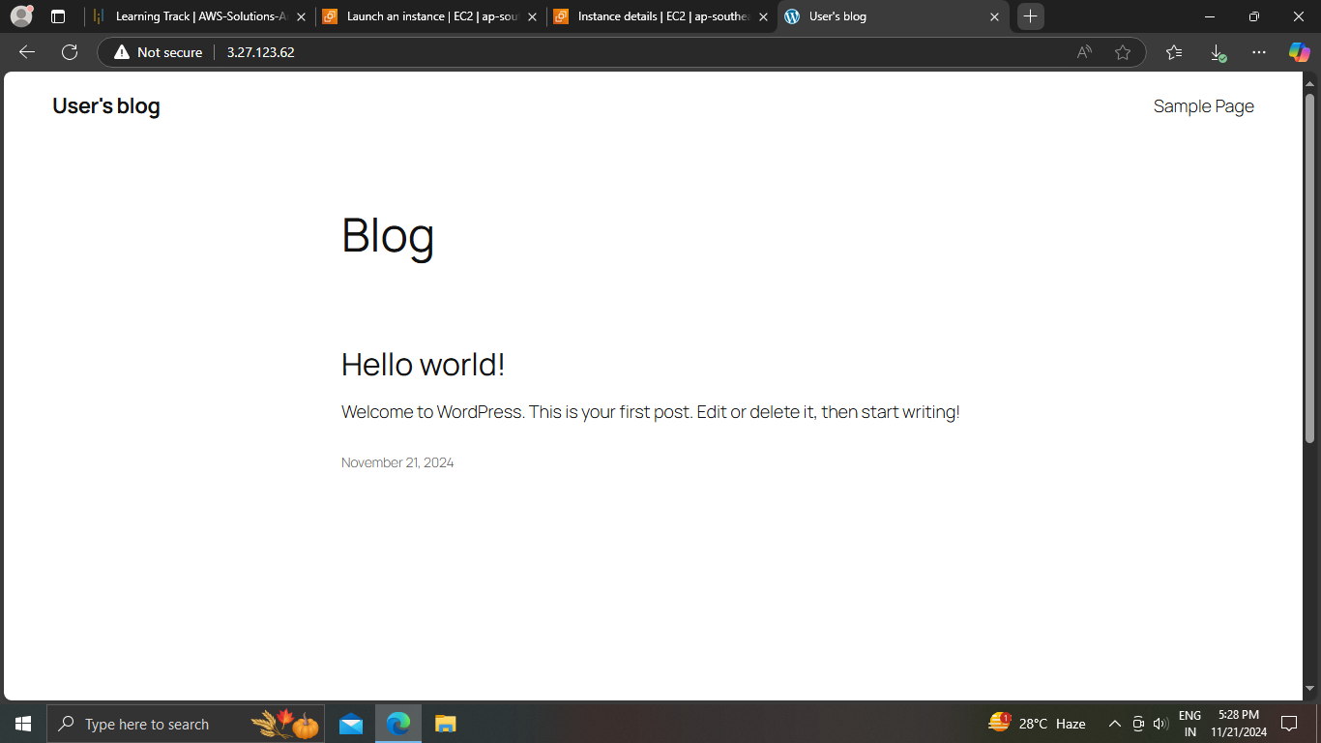

Step 4: System log

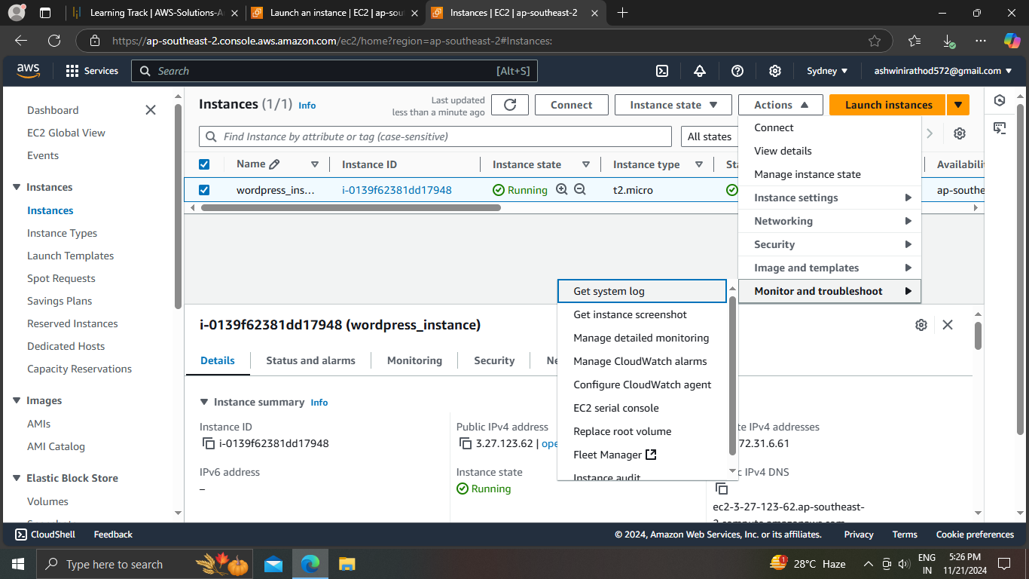

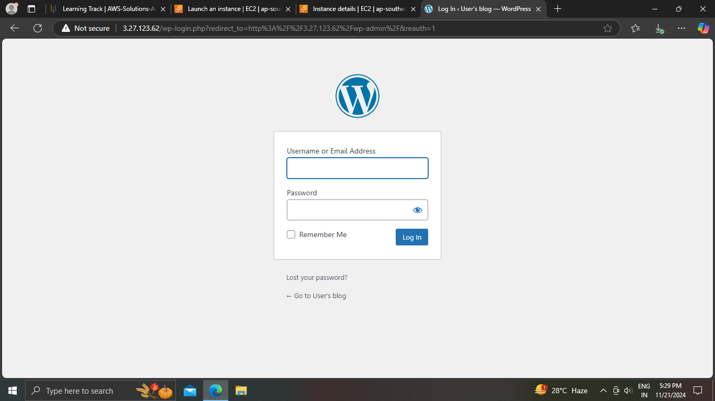

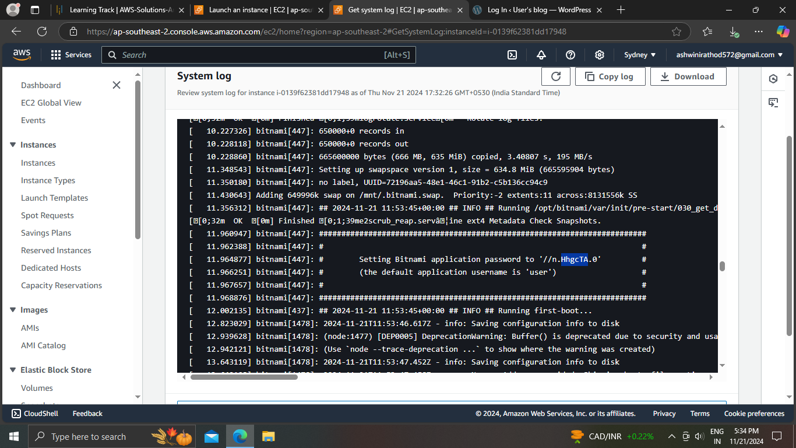

Step 5:Wordpress

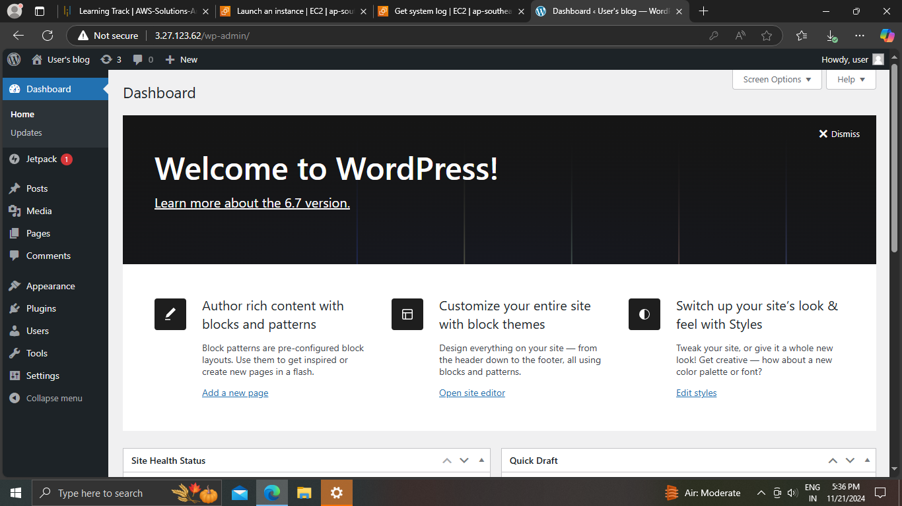

Step 6:Plugins

